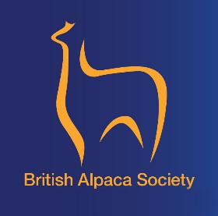

Alpaca Assessment (Foundation)

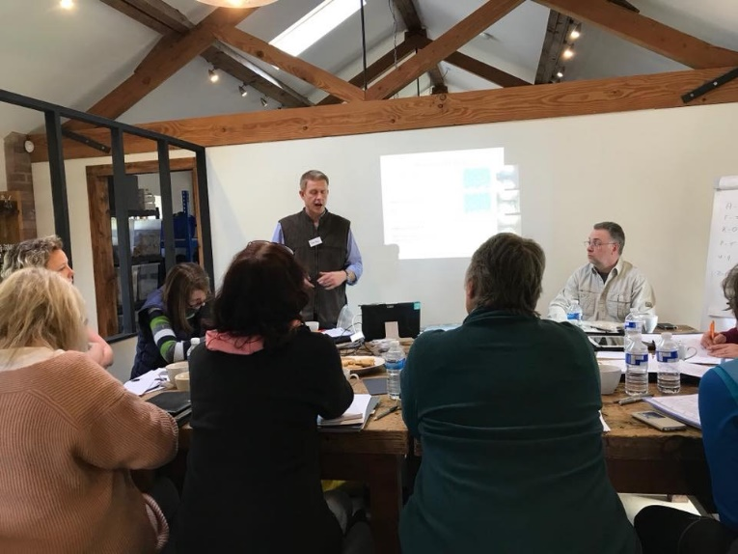

The British Alpaca Society Course offers the following value to members:

A thorough overview of the major fleece performance and conformational traits for both suri and huacaya alpacas. This enables delegates to:
- gain confidence to assess and verbally deliver fibre and conformational characteristics to other owners and potential customers.
- make informed selection decisions within their own herd, at shows and when buying stock in.
- gain the necessary information to make appropriate breeding choices.
- a great place to share information about all aspects of alpaca ownership with other enthusiastic alpaca owners.
- gain valuable experience at handling and assessing a high number of alpacas of varying quality, sex and type.

Suitable for all members and overseas guests who are interested in learning more about assessing conformational and fibre traits. Owners with less than 2 year’s experience in breeding alpacas MUST complete the BAS Alpaca Evaluation course before proceeding with the Alpaca Assessment (Foundation) course.

When: 27th, 28th, 29th November 2020 (Fri, Sat, Sun)

Where: Yeat Wood Farm, Wooton Underwood, Buckinghamshire HP18 0RL

Tutors: Mrs Mary-Jo Smith and Mr Tim Hey

Price: £ 395 plus VAT for Members and £495 plus VAT for non-members
Up to 16 places are available for this course on assessing alpaca conformation and fleece. This course is a comprehensive package in basic alpaca assessment and applicable to all, as well as being a prerequisite for those wishing to enter the BAS judge training scheme.
The course will only run if the minimum number of 12 delegates is met. A place can be secured by booking with Duncan and making your course payment via Grassroots.
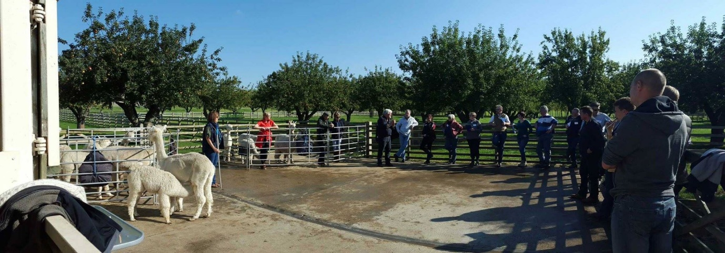
A Covid risk assessment has been made and systems are in place to minimise risk. This is a business gathering so the rule of 6 does not apply.
In the event of a cancellation for Covid (or other) reasons a full refund will be made.
Contact Duncan using ceo@bas-uk.ocm or 07496 578781 to make a booking or for any questions.

