LIZ BARLOW
1, Nash’s Farm, Aston Abbotts, Aylesbury
Bucks, HP22 4NT
Tel: 01296 682605 Mobile: 07976 671701
e mail: liz@livanti.com
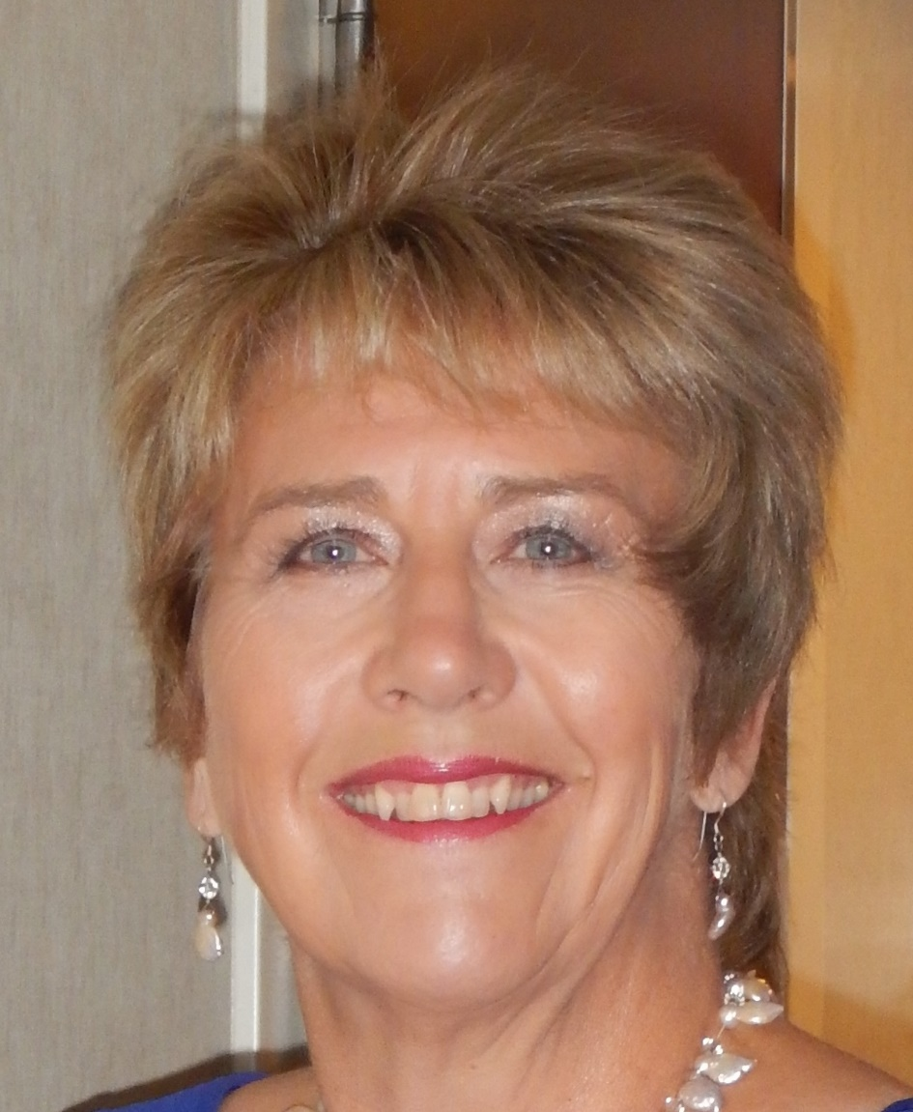
Profile
Liz is a farmer’s daughter who has been involved with animals for most of her life. Raised on a mixed farm, she helped to look after cattle, pigs and horses from a very young age. She had her own pony from the age of 5 and was heavily involved in the local Riding Club.

She and her husband started breeding Alpacas in 1999 with two pregnant females and they increased their herd though a selective breeding and purchase programme, growing it into a successful enterprise. Liz joined the BAS and BCL before purchasing her alpacas and as a keen learner has made every effort to find out as much as she can about the care, breeding and fibre of alpacas. She was the driving force behind the first independent breeder’s alpaca auction in March 2003 and was an active member her local alpaca group. She began showing Alpacas in 2000 and has had champion alpacas in 2000, 2002, 2004, 2006, 2008 and 2009 & 2010. She undertakes screening assessments for the B A S. Livanti Alpacas was sold in 2012 to Liz’s sister Jacki Barlow who also owns Beacon Alpacas.

Liz is a BAS qualified judge and has re certified 5 times. She was chair of the BAS Judges group from 2009 to 2012; she was one of the first three UK accredited Alpaca Breeders Fibre School breeders and is a tutor on BAS courses. Since she began judging in 2003 she has judged both Huacaya and Suri fleece and halter classes, in the UK and Europe.

2019
March BAS National Show, Telford – Suri and Huacaya Females – 2 days Champions with Molly Gardner
March Alpakashow, Alsfeld, Germany – Fleece and Halter – Huacaya & Suri - 2.25 days
May South of England Halter Show – Huacaya and Suri - 2 days
Oct Heart of England Fleece Show – Huacaya and Suri - 1.5 days
Nov Due to Judge Midlands Championship Halter Show – Huacaya and Suri - 1 day

2018
March BAS National Show, Telford – Suri and Huacaya Females – 2 days
March BAS National Fleece Show – Suri and Huacaya Fleeces - 50% of entries
June Royal Bath and West Halter Show – 150 Huacaya and Suri over 2 days

2017
Nov Anniversary Show – Helskini, Finland. Huacaya and Llama Halter and
Huacaya Fleece show and educational seminar
Oct Heart of England Fleece Show – Suri and Huacaya – 105 fleeces over 2 days
May Cornwall Alpaca Show – 45 alpacas

2016
May North Somerset Halter Show – Suri and Huacaya – 1 day
June Three Counties Halter Show – Suri and Huacaya – 1 day
July Alpaca Association of Ireland Show – Fleece, Halter and commentary- 2 days
July Eastern Regional Fleece Show – Huacaya and Suri – 1 Day

2015
March Chief Steward - Heart of England Alpaca Fiesta – 2 days
May South of England Halter Show – Huacaya and Suri - 2 days

2014
March Swiss National Show – Fleece & Halter; Huacaya & Suri– 2 days
May Devon County Show - Halter; Huacaya & Suri - 3 days
June Irish National Show – Halter - Huacaya – 1 day
Sept French Show – Huacaya & Suri; fleece and Halter – 2 days
Oct Heart of England Fleece Show – 2 days

2013
May British Alpaca Society National Show – Females – 2 days
June Armagh Show – Northern Ireland
Aug Ellingham Short Fleece Show
Nov SWAG Autumn Show – Males

2012
March British Alpaca Futurity – Huacaya Fleeces (approx 130)
April Alpaca 2012: Huacaya Male Halter classes & Championships with Mr Harrington – Smith
May Drymen Show Scotland – Halter classes (Approx 50 Huacaya)
June Royal Bath and West - Suri Halter Classes (40 suris)
Sept Italian Alpaca Society Show – Halter Classes (Approx 50 Suri and Huacaya)
October Germany – Alpaka Show 2012 – Halter & Fleece Classes - Suri & Huacaya Approx 300

2011
March British Alpaca Futurity - Halter Classes – 2 days - 350 alpacas
March Sweden - National Halter Show – 1 day
April Germany – AZDV - 2 day Halter Show
April 1st Alpaca Halter Show in Northern Netherlands – 1 day
May South of England Halter Show – Huacaya and Suri – 2 days
Sept Westmorland Show – Short Fleece Halter Show - 1 day

2010
March France – Fleece & Halter Classes – 2 days
April AZDV (Germany) - Fleece and Halter Classes – 2 Days
Aug Hontion Show – short fleece halter classes.
Oct Yorkshire Alpaca Group Show – Short Fleece Halter Show
Oct German Fleece Show

2009
May Royal Bath and West Show – Halter Classes – 4 days
July Royal Show – Stoneleigh – Composite Show
Sept Westmorland Show – Short Fleece Halter Classes

2008
May Drymen Show – Scotland - Halter Classes
June Royal Bath and West Fleece Show (140 fleeces)
June Three Counties Show – Halter Classes
July Kelso Show – Composite Show
August North Devon Show – Fleece and Halter Classes

2007
May BAS National Show with Lyn Dickson - Australia

2006
May 9th Councours European D’ Alpagas et Lamas, Dordogne, France
May Apprentice to Rick Hodgson for Junior females at BAS National Show
May Northumberland County Show (BAS)
June Kenilworth Show (BAS)

2005
June Apprentice Royal Bath & West Show (BCL) Jnr & Int Huacaya Classes
June Kenilworth Show (BAS)
June Three Counties Show (BAS)

2004
May South of England Show (BCL)
June Three Counties Show (BAS)
September Henley Show

2003
May South of England Show (BCL)
June Classes with Amanda VandenBosh at Royal Show
Sept Henley Show
Nov National Fleece Show (BCL/British Alpaca)

She has been approved by the BAS to deliver all their training courses including Alpaca Evaluation for breeders, Foundation and Advanced Alpaca Assessment & Judge training. She played a key role in designing and implementing the BAS Affiliate Scheme including the Practical Alpaca Breeders training.

Liz continues to keep herself up to date by attending training & seminars; she has visited Peru 3 times for alpaca related events and training. Details of all the courses and seminars that she has attended are available from liz@livanti.com.

